**World Happiness Report – GDP vs. Happiness Correlation**

**Introduction**

The World Happiness Report is a landmark survey of the state of global happiness, ranking countries based on various indicators that reflect quality of life and well-being. The core metric used is the Happiness Score, derived from factors such as GDP per capita, social support, life expectancy, freedom to make life choices, generosity, and perceptions of corruption. Published annually, this report provides valuable insights into what makes societies thrive and how countries compare in fostering happiness among their populations.

This project seeks to analyze the World Happiness Report data across multiple years to better understand the economic and social drivers of happiness. Through statistical analysis, data visualization, and clustering techniques, we aim to answer key questions such as:

* Which countries consistently rank highest in happiness, and what factors contribute to their success?
* Is there a strong correlation between a country’s economic performance (GDP per capita) and its happiness score?
* How do non-economic factors like social support, freedom, and perceptions of corruption impact overall well-being?
* Has global happiness improved or declined over recent years?

The ultimate goal is to identify patterns and actionable insights that can inform policy recommendations for governments and organizations striving to improve the well-being of their citizens.

**Correlation Analysis: Key Insights**

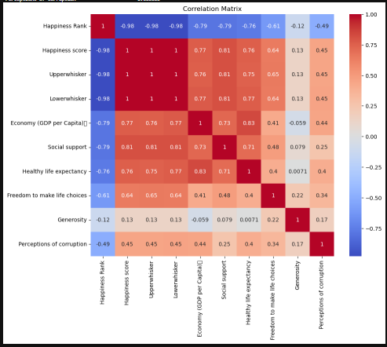

The correlation matrix reveals the strength and direction of linear relationships between key variables in the World Happiness Report:

* Happiness Score shows strong positive correlations with:
  + Social support (0.75)
  + GDP per capita (0.79)
  + Healthy life expectancy (0.77)
  + Freedom to make life choices (0.53)

These findings suggest that countries with stronger economies, better healthcare, robust social systems, and greater personal freedom tend to report higher happiness.

* Perceptions of corruption has a moderate positive correlation (0.45) with happiness, indicating that in less corrupt societies, people tend to be happier.
* Generosity, interestingly, has a low correlation (0.13) with happiness score, suggesting it might not be a major driver at the country level, or its effect could be non-linear or influenced by cultural context.
* Happiness Rank is negatively correlated with happiness score (-0.98), which is expected because a lower rank value (e.g., 1st place) means a higher happiness score.

This matrix confirms that economic strength alone isn't enough—social and institutional quality are equally important in fostering national well-being.

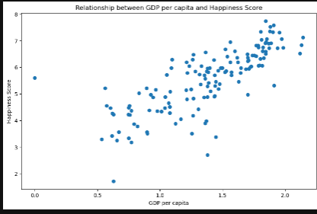

This scatter plot effectively illustrates the **positive relationship between GDP per capita and Happiness Score**.

### 🧠 Interpretation:

* There is a **clear upward trend**, indicating that as **GDP per capita increases**, **Happiness Score also tends to rise**.
* The data points cluster more tightly at higher GDP values, which may suggest **diminishing returns** — i.e., increases in wealth beyond a certain point yield **smaller gains in happiness**.
* Some outliers exist (e.g., countries with moderate GDP but relatively high happiness), which implies that **non-economic factors also play a significant role**.

This chart confirms that economic prosperity is a strong but not exclusive driver of happiness. While GDP per capita provides a solid foundation for well-being, countries aiming to boost happiness must also invest in social cohesion, healthcare, governance, and freedom.

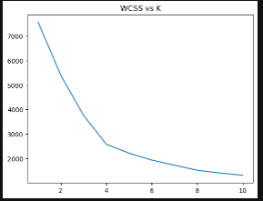

**Elbow Method** using **WCSS (Within-Cluster Sum of Squares)** to determine the optimal number of clusters (K) for K-Means clustering.

### 🔍 Interpretation:

* The WCSS value **decreases sharply** as K increases, which is expected — more clusters reduce within-cluster variance.
* The **"elbow point"** appears around **K = 3 or 4**, where the rate of decrease in WCSS starts to slow significantly.
* This suggests that **3 or 4 clusters** likely offer the best balance between model simplicity and capturing distinct groupings in the data.

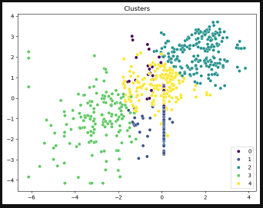

This scatter plot visualizes the **KMeans clustering results** (with **K=5**) after dimensionality reduction (likely using **PCA** or **t-SNE**).

### 🧠 Interpretation of Clusters:

* The points are grouped into **5 distinct clusters**, each represented by a different color (labeled 0–4).
* This indicates that countries (or data points) naturally fall into **5 happiness profile groups** based on features like **GDP per capita, social support, life expectancy, freedom**, etc.
* The clustering reveals:
  + **Groupings of similar well-being profiles**, not necessarily by geography.
  + **Outliers or unique cases**, visible where a few points are isolated or tightly clustered apart from others.

## ****Summary****

This project explored the World Happiness Report to understand the key factors influencing happiness across countries. Through statistical analysis, correlation exploration, and clustering, we identified meaningful patterns and insights into what drives national well-being.

### ****Key Findings:****

* **GDP per capita**, **social support**, and **healthy life expectancy** show the strongest positive correlations with happiness scores, indicating that both economic and social conditions play critical roles in overall well-being.
* A **strong positive relationship** exists between GDP per capita and happiness score, though returns diminish at higher income levels, highlighting the importance of non-economic contributors.
* **Perceptions of corruption** and **freedom to make life choices** also significantly impact happiness, emphasizing the role of governance and civil liberties.
* **Generosity** shows a weaker correlation, suggesting cultural or reporting factors may influence this metric.
* Global happiness trends remain relatively stable over the years, but notable fluctuations exist across countries and regions.
* Clustering analysis (KMeans) revealed **five distinct groups** of countries based on happiness-related features, helping to categorize nations into similar socio-economic profiles.

### ****Conclusion:****

Happiness is a **multifaceted outcome** shaped by economic prosperity, social cohesion, institutional trust, and individual freedoms. While wealth contributes significantly, the most successful countries in terms of happiness combine strong economies with robust social systems and good governance.